Homework 3

1.

a. True

* MLE assumes the binomial distribution of tosses and the independence among tosses. Given, the same number of 60 heads and 40 tails, coins and thumbtacks share the same MLE.
* However, MAPs of coins and thumbtacks are different due to the difference in Beta distributions.

b. False

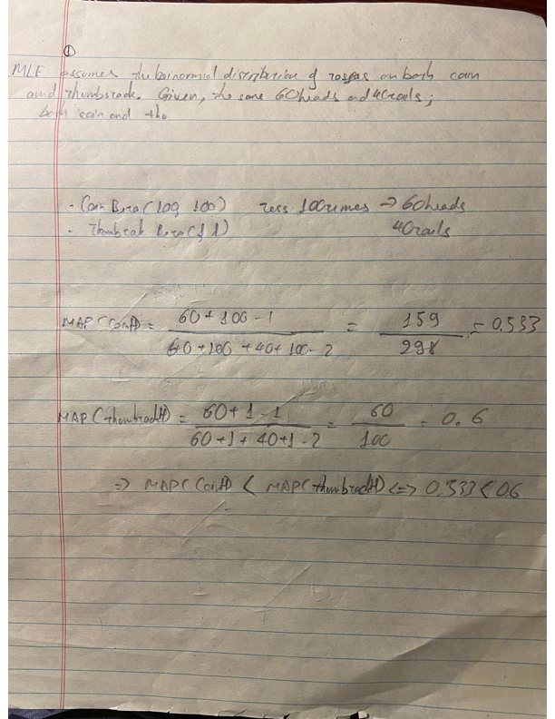

2.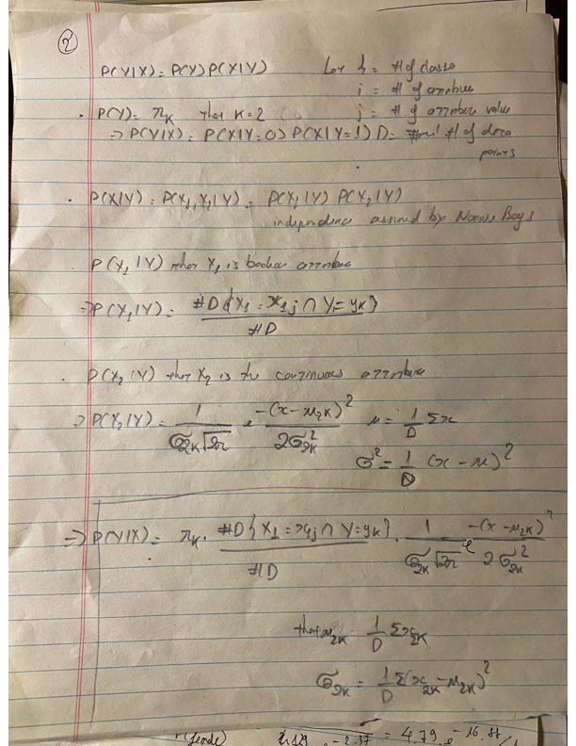

3.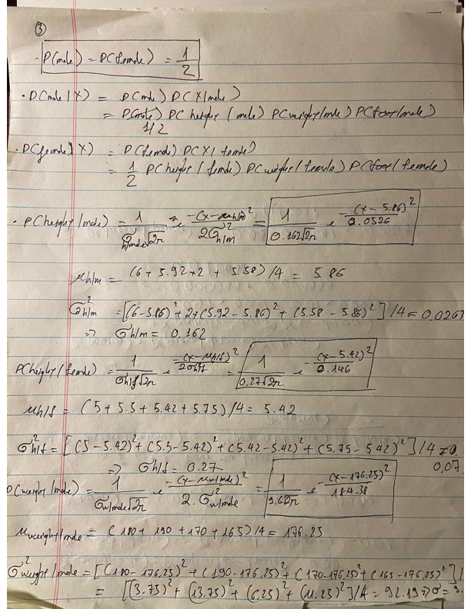

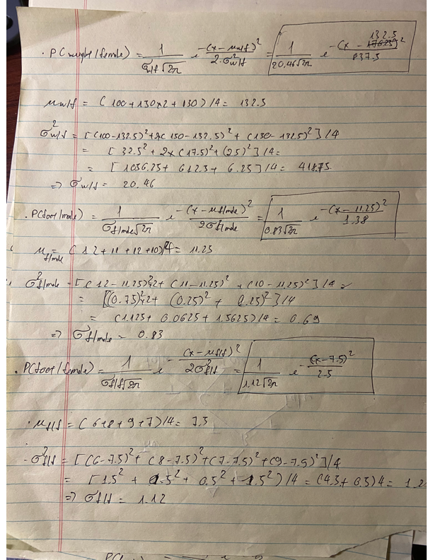

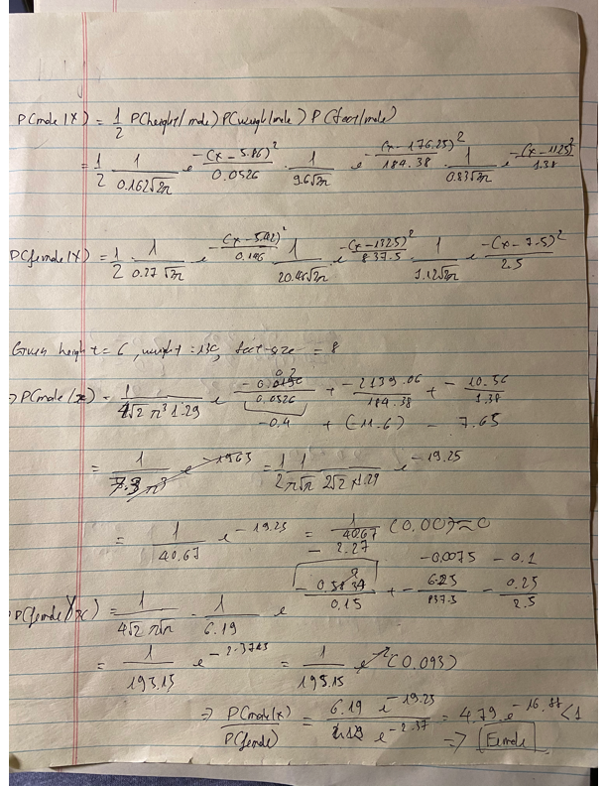

4.

a.

Look at the figure, the data is linearly separable. Hence, the logistic regression will find a line that fits the data perfectly. As a result, the drawn line yields no classification error. The line is not unique.

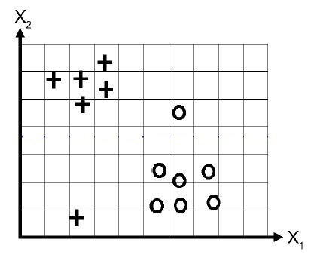

b.

When w0 = 0, the means that the decision boundary must passes the origin point (0, 0). Look at the figure, there is 1 classification error.



c. When w1 is regularized only, then w1 = 0. Then, the decision boundary found by the logistic regression is a horizontal line. Look at the figure, there is 1 classification error



d. When w2 is regularized only, then w2 = 0. Then, the decision boundary found by the logistic regression is a vertical line. Look at the figure, there is no classification error.



5.

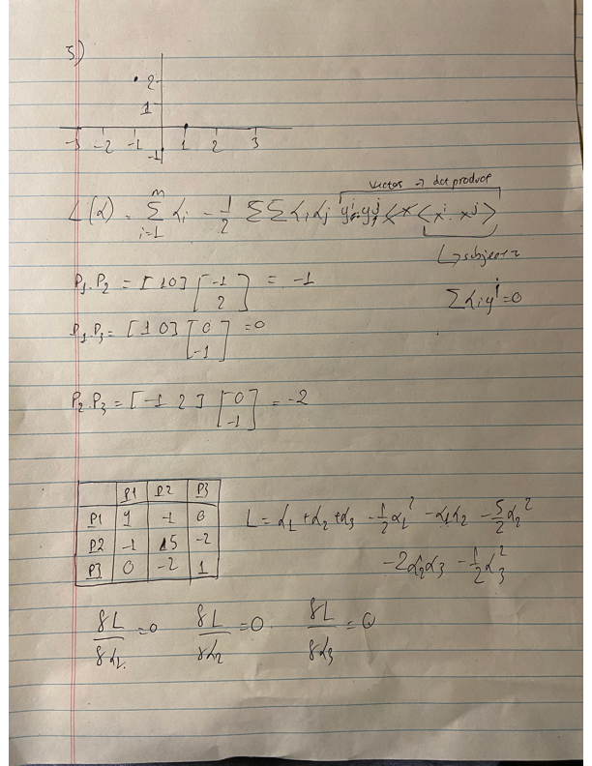

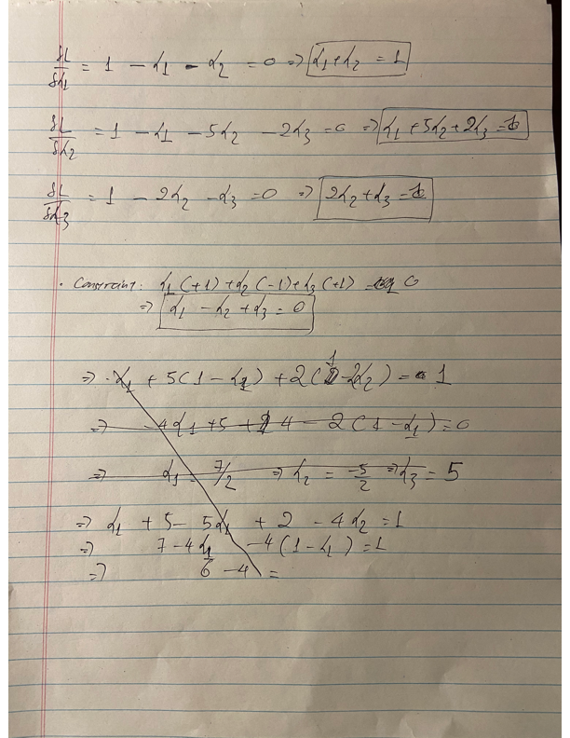

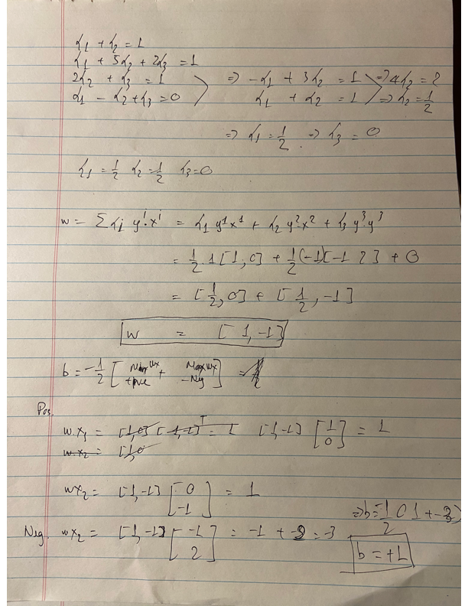

6.